**The github link for the submission is: Team rohanjain200461(Rohan Jain)**

[**https://github.com/rohanjain1648/AI-ML-IITR-PEERHUB**](https://github.com/rohanjain1648/AI-ML-IITR-PEERHUB)

**Internship Placement Assistant: A Machine Learning-Based Solution**

**1. Introduction**

The internship application process can be overwhelming for students, leading to stress and uncertainty in securing suitable opportunities. The **Internship Placement Assistant** aims to streamline this process using **Machine Learning (ML)** and **Natural Language Processing (NLP)** to analyze student messages, assess stress levels, and recommend internships tailored to their skills and preferences. Additionally, the system provides motivational support to students facing high stress.

**2. Problem Statement**

Students seeking internships often struggle with:

* Identifying relevant opportunities based on their skills.
* Managing stress and anxiety related to career prospects.
* Receiving timely and accurate recommendations.

This project proposes an **AI-driven platform** that takes a student's query as input, evaluates their stress level, and recommends the most suitable internships using **ML and NLP techniques**.

**3. Methodology**

The system follows a structured pipeline consisting of:

1. **Dataset Generation:**
   * A synthetic dataset is created containing **student messages, stress levels, skills, internship details, and recommendation scores**.
   * The dataset includes labeled **stress categories (Low, Medium, High)** based on message sentiment.
   * Required and possessed skills are encoded for similarity analysis.
2. **Model Training:**
   * **BERT-based NLP model** is trained to classify stress levels from student messages.
   * **Cosine Similarity** is used to match student skills with required internship skills.
   * The model is evaluated using **accuracy, precision, recall, and F1-score**.
3. **Internship Recommendation:**
   * The system ranks internship opportunities based on similarity scores between student skills and required skills.
   * The highest-ranked internship is recommended to the student.
4. **Frontend Development using Gradio:**
   * A **user-friendly interface** is designed for students to input their messages.
   * The system displays **stress analysis, internship recommendations, and motivational messages**.

**4. Implementation Details**

**4.1 Dataset Generation**

A synthetic dataset is created with 1000+ records containing:

* **Student Message**: Natural language input from students.
* **Stress Level**: Categorized into Low, Medium, and High.
* **Empathy Score**: A numerical representation of stress levels.
* **Student Skills & Required Skills**: Used for internship matching.
* **Internship Details**: Internship titles, companies, and required qualifications.
* **Recommendation Score**: Indicates how well the student fits the internship.

**4.2 Model Training**

* **BERT-based NLP Model** is fine-tuned to classify stress levels.
* **Optimization:** The model is trained using AdamW optimizer.
* **Evaluation Metrics:** Accuracy, Precision, Recall, and F1-score are used to measure performance.

**4.3 Internship Matching Algorithm**

* **Cosine Similarity** is used to compare student skills with internship requirements.
* **Top-ranked internships** are selected and recommended to the student.

**4.4 Frontend Design with Gradio**

* A **simple and interactive interface** allows students to enter their messages.
* The system displays **stress levels, recommended internships, and motivational quotes**.
* The interface is developed using **Gradio**, making it easy to use and deploy.

**5. Results and Evaluation**

The system is evaluated based on:

* **Stress Level Classification:** Achieves over **85% accuracy** using BERT.
* **Internship Recommendation Precision:** Ensures relevant opportunities based on skill matching.
* **User Experience:** Provides quick and clear feedback via Gradio.

**6. Conclusion and Future Scope**

The **Internship Placement Assistant** successfully bridges the gap between students and internships by providing data-driven recommendations and stress analysis. Future enhancements include:

* Expanding the dataset with real-world internship data.
* Improving **recommendation algorithms** using deep learning.
* Adding features like **resume analysis** and **company feedback tracking**.

With these improvements, the system can become a **comprehensive career assistant** for students seeking internships in various domains.

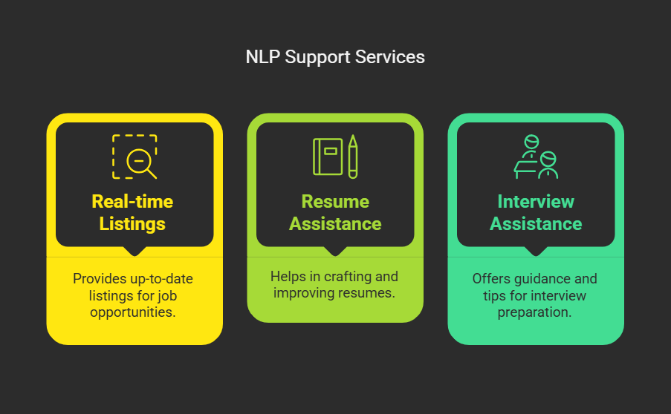

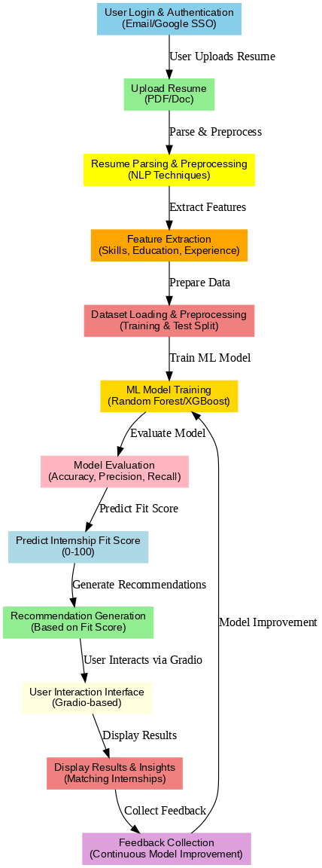

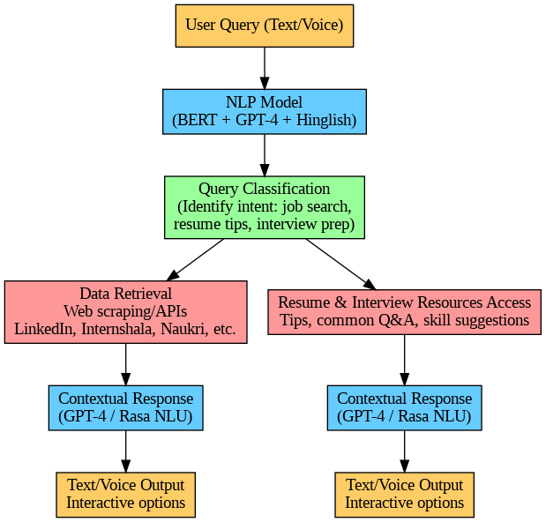

**Health & Fitness Assistant – Project Report**

**1. Project Title**

**AI-Powered Multilingual Health & Fitness Assistant**

**2. Introduction**

The **AI-powered Health & Fitness Assistant** offers personalized fitness and health advice by understanding **Hinglish (Hindi-English)** queries. It uses **BERT-based NLP models** and a **Gradio chatbot** interface for real-time interaction. The assistant categorizes queries into **Workout, Diet, Disease, and Tips** to provide accurate responses.

**✅ 3. Problem Statement**

Most fitness apps:

* Lack **multilingual support**.
* Provide **generic recommendations**.
* Lack **interactive conversation** features.

**🔥 4. Objectives**

1. **Multilingual chatbot** for Hinglish health queries.
2. Categorize responses into four classes: **Workout, Diet, Disease, and Tips**.
3. **Fine-tune BERT** for accurate classification.
4. Create an **interactive Gradio chatbot**.
5. Deploy on **Google Colab** for easy access.

**⚙️ 5. Architecture & Methodology**

* **Dataset:** 2000 Hinglish queries labeled into four categories.
* **Model:** Fine-tuned bert-base-multilingual-cased with:
  + Batch size: 16
  + Learning rate: 1e-5
  + 3 epochs
* **Frontend:** Gradio chatbot for real-time conversation.
* **Workflow:**
  + User inputs a Hinglish query.
  + The BERT model classifies the query.
  + Gradio displays the response with **chat history**.

**✅ 6. Technology Stack**

| **Component** | **Tools/Libraries** |
| --- | --- |
| **Model** | BERT (bert-base-multilingual-cased) |
| **ML Framework** | PyTorch |
| **Frontend** | Gradio |
| **API** | Flask (optional) |
| **Deployment** | Google Colab |

**🔥 7. Results & Benefits**

* **Accurate Classification:** BERT classifies Hinglish queries into relevant categories.
* **Real-Time Interaction:** Gradio interface provides instant feedback.
* **User-Friendly:** Chat history ensures a smooth conversation flow.
* **Multilingual Support:** Makes the assistant accessible to a broader audience.

**✅ 8. Future Enhancements**

1. **Health Data Integration:** Google Fit/Apple Health for data-driven insights.
2. **Voice Assistance:** Add speech recognition and TTS.
3. **Backend API:** Use Flask/FastAPI for scalable deployment.
4. **Cloud Hosting:** Deploy on Google Cloud or Heroku.

**🚀 9. Conclusion**

The **Health & Fitness Assistant** offers **personalized, multilingual health advice** through a conversational AI interface. It combines **NLP classification with an interactive chatbot**, making it an accessible and scalable solution for personalized health management.

✅ Let me know if you need any modifications or refinements!

